OCHRE Steering Committee
The OCHRE Steering Committee (Committee) met on 24 June 2022.

Head of Aboriginal Affairs
The Committee was sorry to hear Head of Aboriginal Affairs NSW (AANSW) Lil Gordon will be leaving the organisation in July, and wishes to acknowledge and thank Lil for her contributions to Steering Committee meetings over the years and wishes her all the very best in her future endeavours. The Committee also welcomes Shane Hamilton as the incoming Deputy Secretary of AANSW.
NCARA
The Committee met with NCARA’s Chair Vickie Parry to hear updates relating to the evaluation from Regional Alliances participating in Local Decision Making.
Evaluation of OCHRE - Local Decision Making
The Committee was pleased to receive updates on the status of the Local Decision Making Accord Negotiation Evaluation reports from the Centre for Aboriginal Economic Policy Research (CAEPR). The Committee was advised that work is progressing well and that the final reports will be ready within a few months.
CAEPR invited the Committee, NCARA and AANSW representatives to a workshop to progress draft evaluation reports and ensure the various community representatives are confident that the reports present their views in the progress of the OCHRE Evaluation.
Review of Local Decision Making
The Committee offered to provide supporting information to the Minister for Aboriginal Affairs as required in relation to the review of Local Decision Making.
The Committee would once again like to express its gratitude and appreciation for the participation of Aboriginal communities in the OCHRE Evaluation. It commends CAEPR for their adaptability in their approach to the evaluation to ensure that Aboriginal voices continue to be heard throughout the entire project.

Wishing everyone all the best,
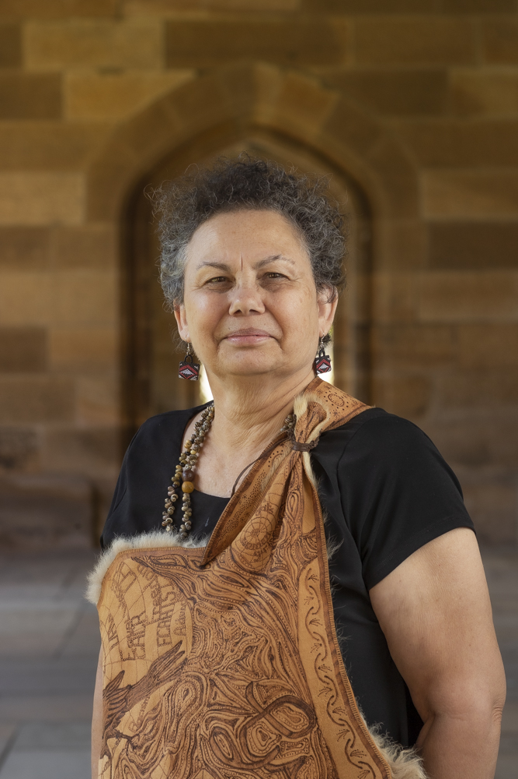
Associate Professor Lynette Riley
Chair, OCHRE Steering Committee

